1-Q
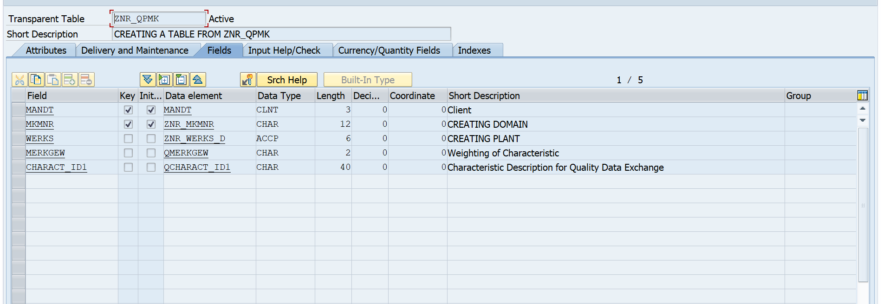
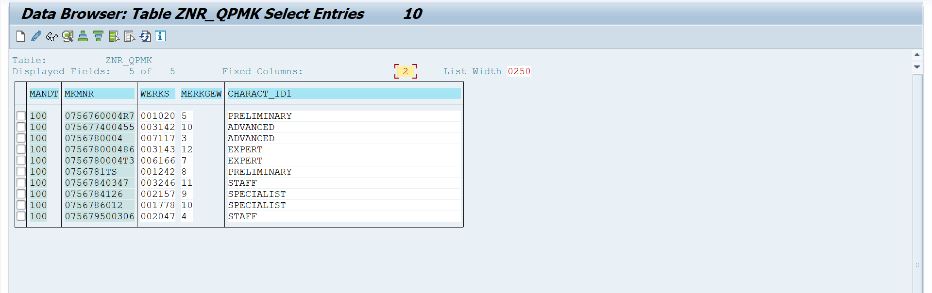
2-Q
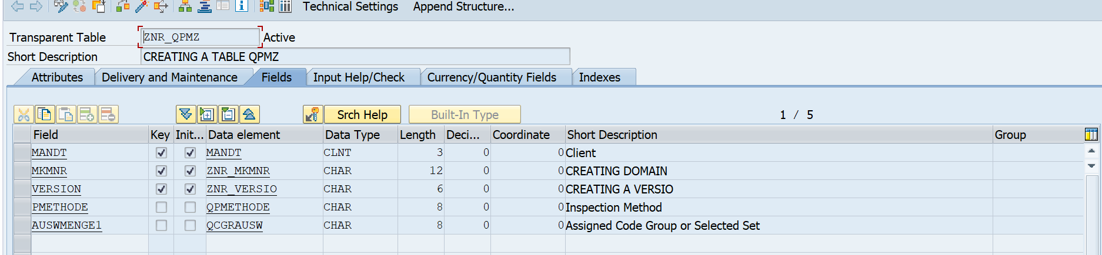
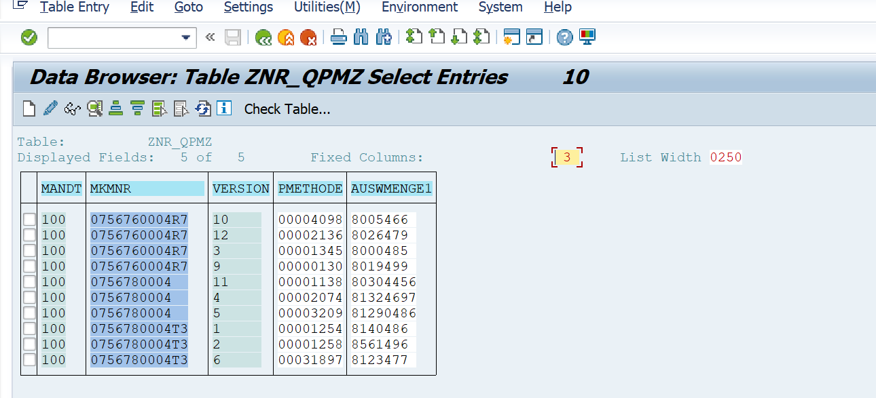
3-Q
*&---------------------------------------------------------------------*
*& Report ZNR_INTERACTIVE
*&---------------------------------------------------------------------*
*&
*&---------------------------------------------------------------------*
REPORT ZNR_INTERACTIVE.
INCLUDE ZNR_INTERACTIVE_TOP.
INCLUDE ZNR_INTERACTIVE_SEL.
START-OF-SELECTION.
SELECT MANDT
MKMNR
WERKS
MERKGEW
CHARACT_ID1
FROM ZNR_QPMK
INTO TABLE gt_ZNR_QPMK.
LOOP AT gt_ZNR_QPMK INTO gs_ZNR_QPMK.
ULINE.
WRITE : / sy-vline, gs_ZNR_QPMK-MANDT,
sy-vline, gs_ZNR_QPMK-MKMNR HOTSPOT,
sy-vline, gs_ZNR_QPMK-WERKS,
sy-vline, gs_ZNR_QPMK-MERKGEW,
sy-vline, gs_ZNR_QPMK-CHARACT_ID1,
sy-vline.
HIDE gs_ZNR_QPMK-MKMNR.
ENDLOOP.
*---------------------------------------------------------------------*
TOP-OF-PAGE.
ULINE.
WRITE : / '*** PRIMARY LIST (Order Master Data) ***'.
*---------------------------------------------------------------------*
AT LINE-SELECTION.
SELECT MANDT
MKMNR
VERSION
PMETHODE
AUSWMENGE1
FROM ZNR_QPMZ
INTO TABLE gt_ZNR_QPMZ
WHERE MKMNR = gs_ZNR_QPMK-MKMNR.
IF sy-subrc = 0.
LOOP AT gt_ZNR_QPMZ INTO gs_ZNR_QPMZ.
ULINE.
WRITE : / sy-vline, gs_ZNR_QPMZ-MANDT,
sy-vline, gs_ZNR_QPMZ-MKMNR,
sy-vline, gs_ZNR_QPMZ-VERSION,
sy-vline, gs_ZNR_QPMZ-PMETHODE,
sy-vline, gs_ZNR_QPMZ-AUSWMENGE1,
sy-vline.
ENDLOOP.
ELSE.
WRITE: / 'No data found'.
ENDIF.
TOP-OF-PAGE DURING LINE-SELECTION.
ULINE.
WRITE : / '*** SECONDARY LIST (Material Master Data) ***'.

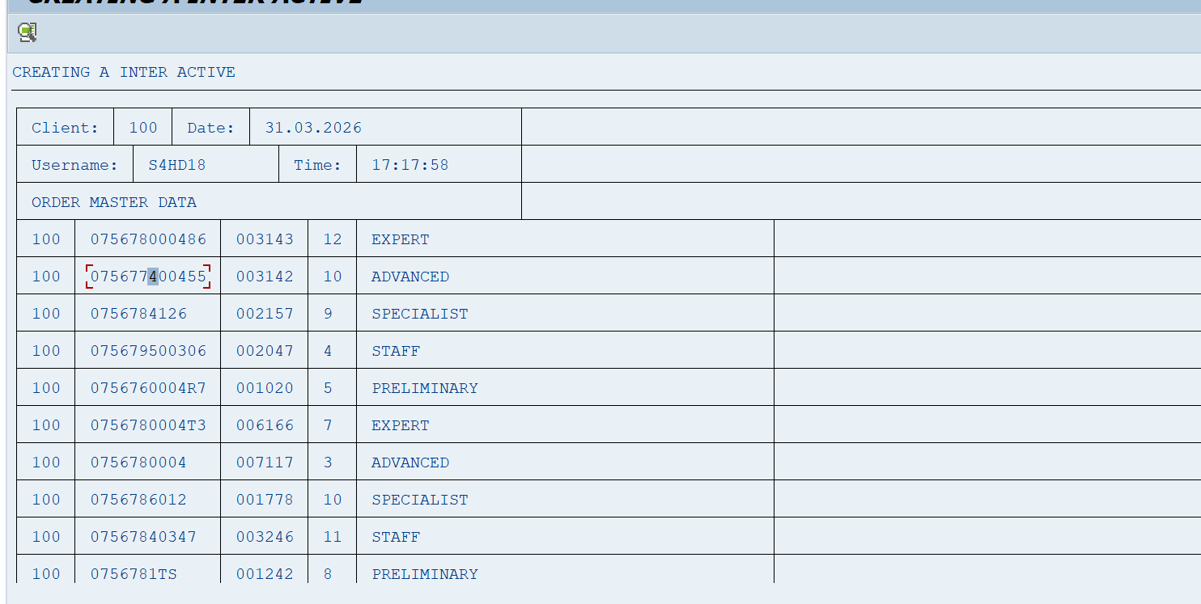
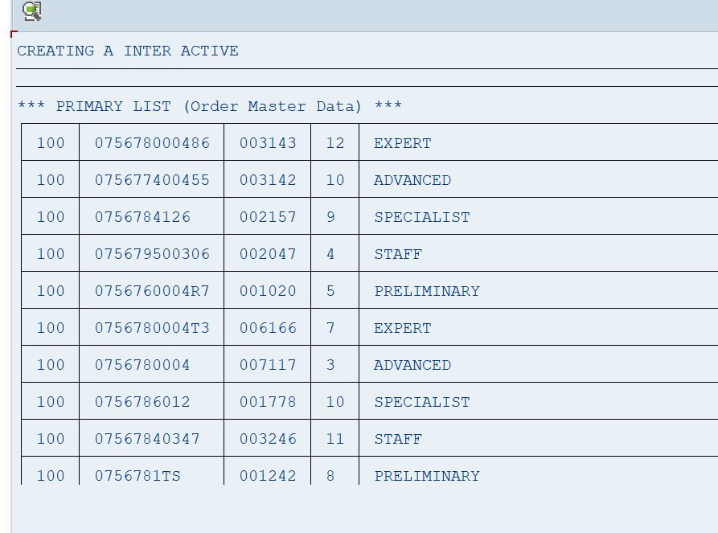

5-Q
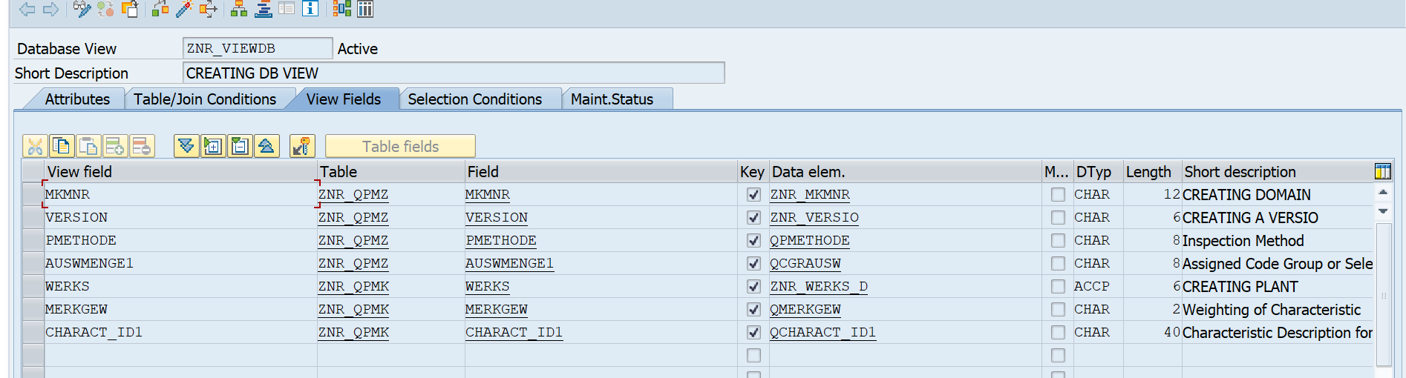
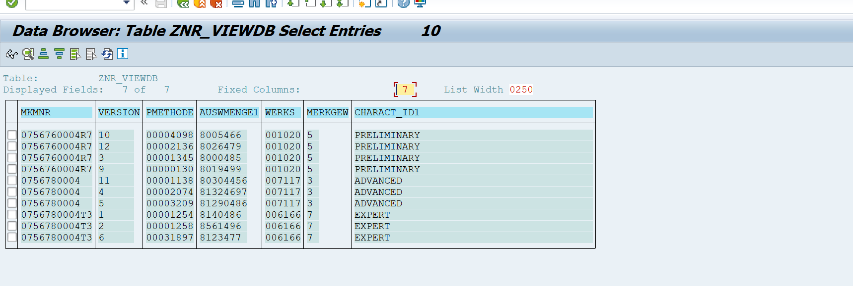
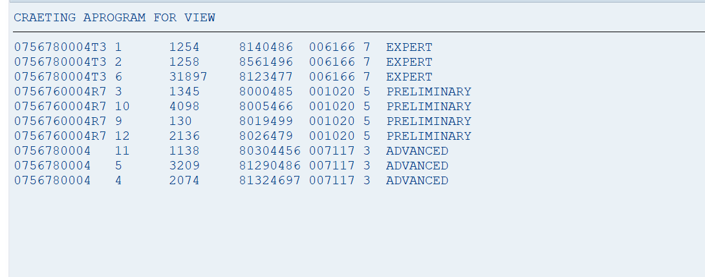

4-Q
